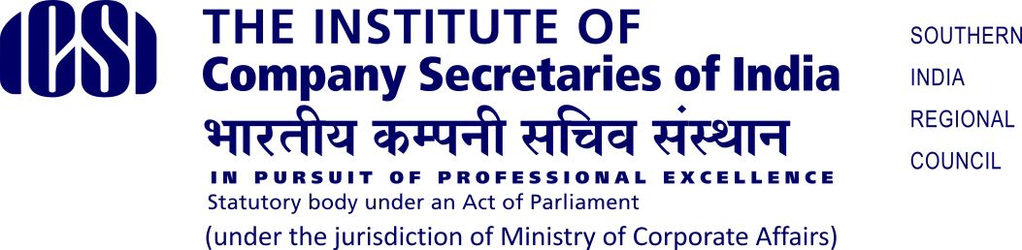

RULES OF 22nd ALL INDIA DEBATE COMPETITION

Eligibility Criteria:

- Participation is restricted to the bonafide registered students of the ICSI. Students will be required to carry their Identity Card of ICSI with them at the time of Competition.

- Practicing Advocates, Chartered Accountants, Cost Accountants are not eligible to participate and the students of ICSI who have cleared all modules of Professional Programme are not eligible to participate.

Pattern of the Competition:

The Debate Competition will be organised at three levels as mentioned below:

- Chapter Level Round on Saturday 07th October 2023
- Regional Level Round on Saturday 21st October 2023
- National Level Round on Saturday 25th November 2023

Registration procedure & Selection:

- At the chapter level, preliminary round will be conducted to select the winner (one student) and runner-up (one student). Such selected students will be nominated for the regional level round.

- First, Second and Third Prize Winners of the Regional Round held at each Regional Council will participate in the National Round of the competition.

Rules:

- Students will have the option to speak either “for the motion” or “against the motion”.

- Each participant will be given a time limit not exceeding 10 minutes to speak on the subject. A warning bell will be given after 8 minutes and a final bell after 10 minutes. If the participants exceed the allocated time than the marks will be deducted at the discretion of the judges.

- The decision of the judge(s) as regards the result of the competition shall be final and binding.

Marking Criteria:
Marks may be awarded as per the following criteria out of the marks allocated against each category.
Sl. No. | Marking Criteria | Marks
1 | Contents/ substance | 25
2 | Oratory skills | 25
3 | Presentation skills | 20
4 | Clarity of thought | 20
5 | Confidence | 10

Fee:
There will be no participation fee for the competition.

Cash Awards / Certificates:

Cash Awards / Certificates will be given as per following details:

Level | First Prize | Second Prize | Third Prize
Chapter Level | Commendation Certificate | Commendation Certificate | Commendation  Certificate
Regional Level | Cash Award of  Rs.10,000/- and  Commendation Certificate | Cash Award of  Rs.6,000/- and  Commendation Certificate | Cash Award of  Rs.4,000/- and  Commendation  Certificate
National Level | Cash Award of  Rs.20,000/- and  Commendation Certificate | Cash Award of  Rs.12,000/- and  Commendation Certificate | Cash Award of  Rs.8,000/- and  Commendation  Certificate

Reimbursement of Travelling Expenses:
Travelling expenses of team of students for participating at various levels of Competitions will be borne by the respective Regional Councils / Chapters as per provisions given below:
- When Chapter’s team is visiting their respective Regional Council to participate in the Regional Round, their travelling expenses will be borne by the concerned Chapter (i.e. to & fro bus fare or train fare of 3rd AC from the place of residence of student to the destination of Regional Round).

- Similarly, when winners of Regional Round are going to participate in the National Round then travelling expenses of students will be borne by the concerned Regional Council. (i.e. to & fro bus fare or train fare of 3rd AC from the place of residence of student to the destination of National Round).

Instruction:
- All participants are expected to maintain decorum in the hall / venue where
the event will be held.
- The Dress Code will be formal.
- The organizers reserve the right to take appropriate action for any unethical, unprofessional, and immoral conduct.
- The organizer’s decision regarding interpretation of rules or any other matter related to competition will be final and binding.
- If there is any situation not contemplated in the rules, the decision of ICSI shall be final.

